to name
penup
lt 90
forward 395
right 90
pendown
left 45
forward 95
back 95
right 45
forward 95
back 95
back 100
forward 200
penup
home
lt 90
forward 395
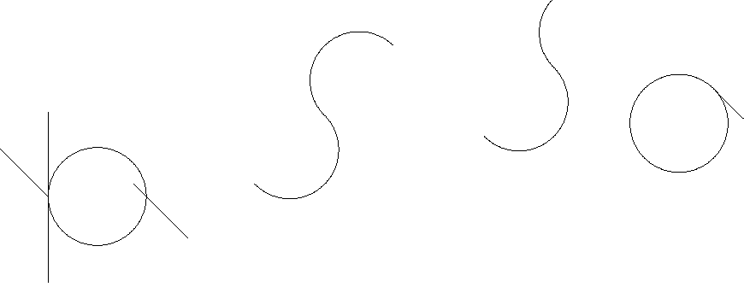
right 90
pendown
repeat 360[forward 1 right 1]
forward 15
penup
right 90
forward 100
right 45
pendown
forward 90
penup
back 90
lt 90
forward 50
forward 50
right 90
forward 100
pendown
repeat 180[forward 1 left 1]
repeat 180[forward 1 right 1]
penup
forward 150
pendown
repeat 180[forward 1 left 1]
repeat 180[forward 1 right 1]
penup
forward 150
pendown
repeat 360[forward 1 right 1]
forward 15
forward 70
end

to othercircle
repeat 360 [forward 1 right 1]
end

to star
manyflowers
manyflowers
home
forward 50
left 15
forward 20
right 10
forward 20
left 15
forward 10
left 45
left 45
right 90
left 90
pendown
end

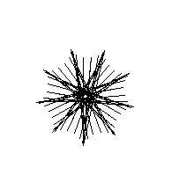

to square
forward 100
left 90
forward 100
left 90
forward 100
left 90
forward 100
end

to rectangle :width :height
forward :height
right 90
fd :width
rt 90
fd :height
rt 90
fd :width
end

TO FLOWER
fd 100
bk 50
rt 90
fd 50
bk 100
fd 50
lt 45
fd 50
bk 100
fd 50
lt 45
fd 50
bk 100
fd 50
rt 45
lt 90
fd 50
bk 100
forward 50
left 135
forward 200
right 90
forward 100
back 100
left 180
forward 100
back 100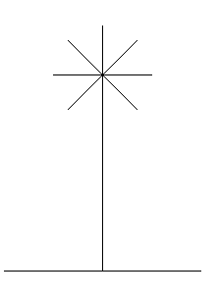
End

to flowergarden
flower
forward 200
back 100
left 90
forward 200
right 90
forward 100
back 100
left 180
forward 50
back 50
right 90
forward 50
back 50
right 45
forward 50
back 50
left 90
forward 50
back 50
right 180
forward 50
back 50
right 90
forward 50
back 50
end
