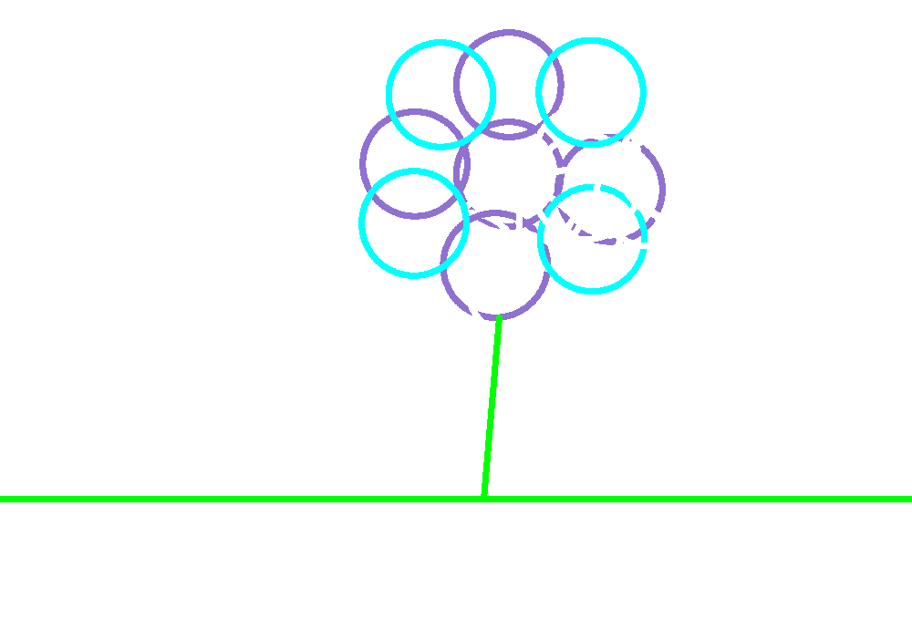
This took forever to make!!

My Flower

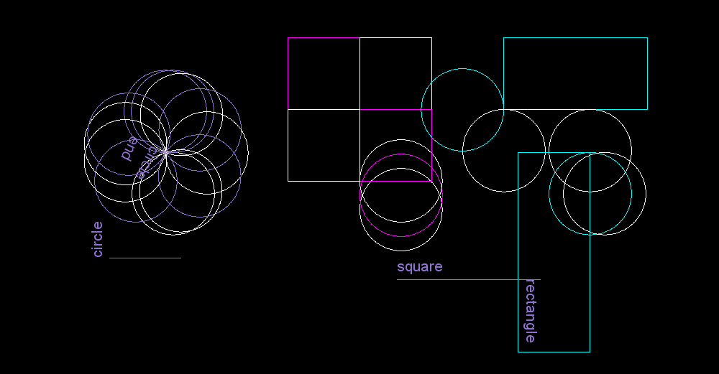 MY Circles, Squares, and Rectangles!!*~*~


Twinkle, twinkle little star….

~~~~MY Name~~~~
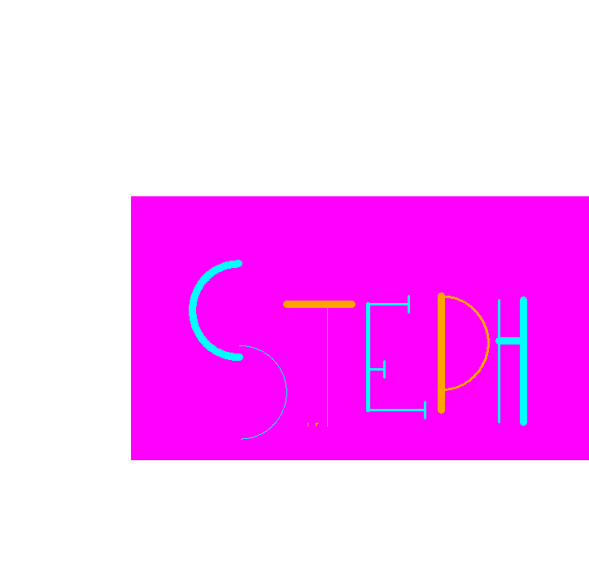

- ~ *Flower Garden*~ *
- 