

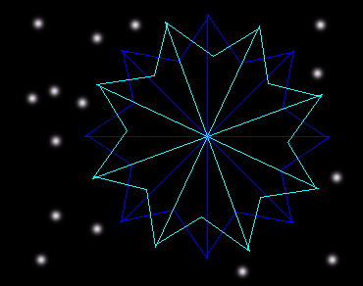
to floower
forward 125
back 125
right 45
forward 125....
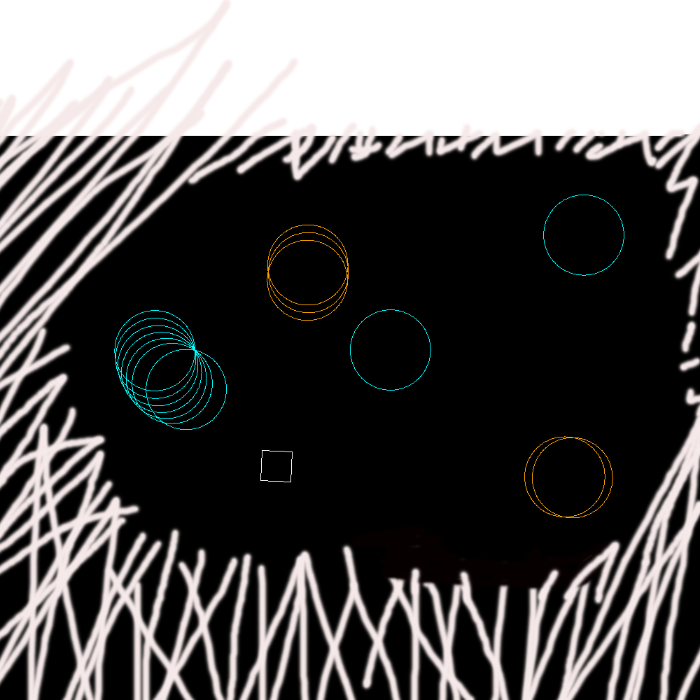

Repeat 360[fd 1 right 1]…
to floower
forward 125
back 125
right 45
forward 125....





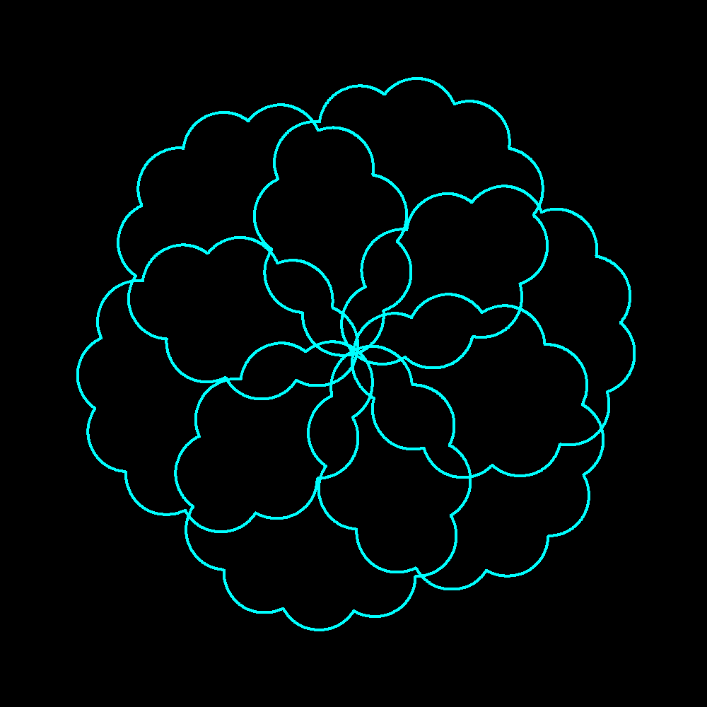 to flower
repeat 115[right 1 forward 1]
left 90
repeat 121[right 1 forward 1]
left 90…

