Liz Brown
My Logo Book

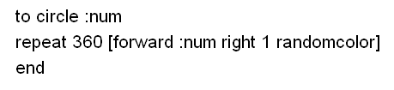

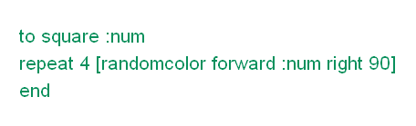

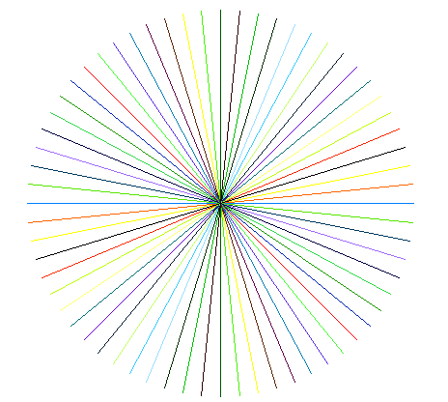

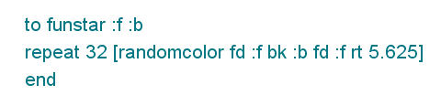
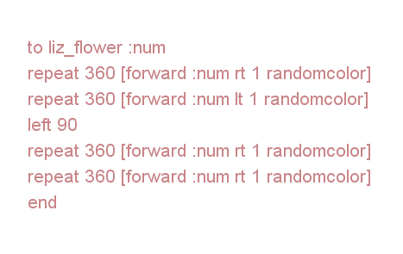
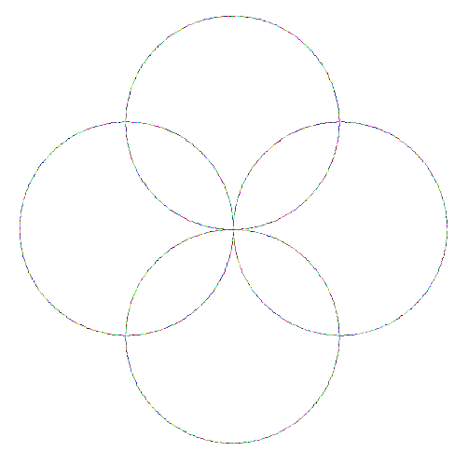





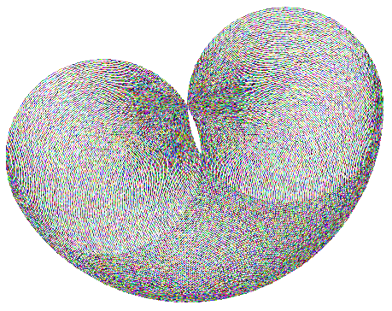

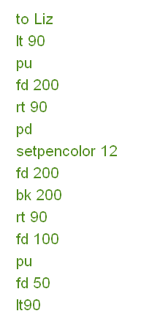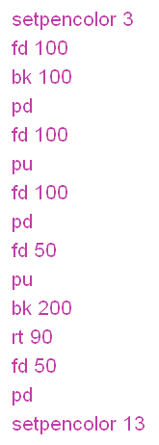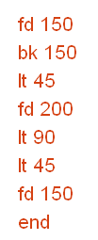

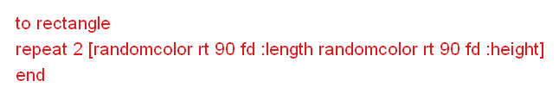
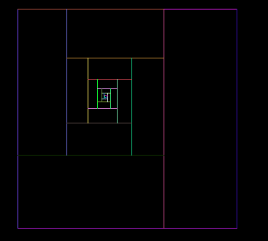
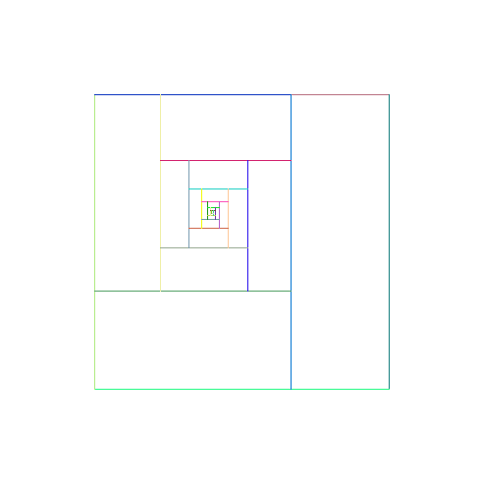
To golden4
Randomcolor
Repeat 4[Right 90 Forward 300 Randomcolor]
Right 90
Forward 200
Right 90
Randomcolor
Forward 300
Back 100
Right 90
Randomcolor
Repeat 2[Forward 200 Back 66.67 Right 90 Randomcolor]
Repeat 2[Forward 133.33 Back 44.44 Right 90 Randomcolor]
Repeat 2[Forward 88.89 Back 29.63 Right 90 Randomcolor]
Repeat 2[Forward 59.26 Back 19.75 Right 90 Randomcolor]
Repeat 2[Forward 39.51 Back 13.17 Right 90 Randomcolor]
Repeat 2[Forward 26.34 Back 8.78 Right 90 Randomcolor]
Repeat 2[Forward 17.56 Back 5.85 Right 90 Randomcolor]
Repeat 2[Forward 11.71 Back 3.9 Right 90 Randomcolor]
Repeat 2[Forward 7.81 Back 2.6 Right 90 Randomcolor]
Repeat 2[Forward 5.21 Back 1.74 Right 90 Randomcolor]
Repeat 2[Forward 3.48 Back 1.16 Right 90 Randomcolor]
End

