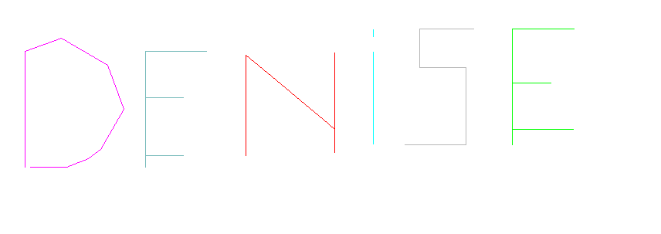
to myname
setpencolor 5
penup
left 90
forward 300
right 90
pendown
forward 150
right 70
forward 50
right 50
forward 70
right 40
forward 60
right 50
forward 60
right 20
forward 20
right 20
forward 30
right 20
forward 48
penup
bk 150
right 90
pendown
setpencolor 11
forward 150
right 90
forward 80
penup
bk 80
right 90
forward 50
left 90
pendown
forward 50
penup
bk 50
right 90
forward 78
left 90
pendown
forward 50
penup
forward 80
left 90
setpencolor 4
pendown
forward 110
right 90
right 40
forward 150
left 130
bk 30
forward 130
penup
right 90
forward 50
right 90
pendown
setpencolor 3
forward 120
penup
left 180
forward 140
pendown
forward 10
penup
right 90
forward 60
setpencolor 15
forward 70
left 90
bk 50
left 90
bk 60.
right 90
bk 100
right 90
bk 80
penup
forward 140
left 90
pendown
setpencolor 2
forward 150
right 90
forward 80
bk 80
right 90
forward 70
left 90
pendown
forward 50
bk 50
right 90
forward 60
left 90
forward 80
penup
end

to rectangle :width:height
forward :height
right 90
fd :width
rt 90
fd :height
rt 90
fd :width
end

to square 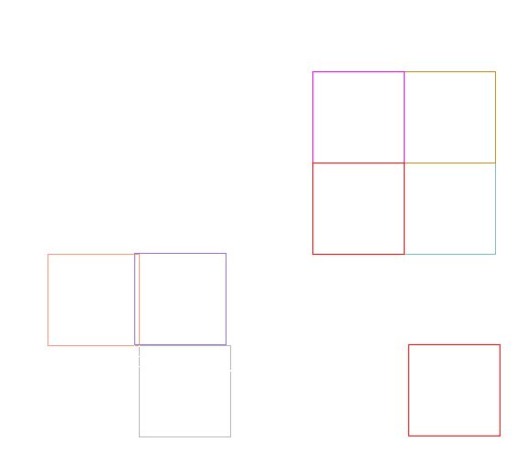
right 90
forward 90
setpencolor 13
right 90
forward 90
right 90
forward 90
right 90
forward 90
End




