

to carolina
setscreencolor 0
setpencolor 4
left 90
repeat 180 [forward 1 right 1]
penup
setpencolor 6
home
right 90
forward 50
left 90
pendown
right 25
forward 120
right 120
forward 120
back 60
right 90
forward 100
penup
back 100
left 90
forward 60
home
setpencolor 1
right 90
forward 200
left 90
pendown
forward 120
right 90
forward 75
right 90
forward 60
right 90
forward 75
left 90
left 45
forward 75
penup
home
right 90
forward 300
left 90
forward 50
pendown
setpencolor 13
repeat 360 [forward 1 right 1]
repeat 180 [forward 1 right 1]
penup
forward 50
left 90
forward 60
left 90
pendown
setpencolor 7
forward 120
back 120
right 90
forward 100
penup
forward 50
left 90
pendown
setpencolor 2
forward 120
back 120
right 90
penup
forward 40
left 90
pendown
setpencolor 3
forward 120
right 160
forward 120
left 160
forward 120
back 120
right 90
penup
forward 50
left 90
pendown
setpencolor 14
right 25
forward 120
right 120
forward 120
back 60
right 90
forward 100
penup
back 100
left 90
penup
home
pendown
end



to square1
repeat 4 [forward 100 right 90]
end



to flower1
repeat 8 [triangle right 103]
left 105
back 220
forward 50
right 45
repeat 75 [forward 1 right 1]
right 100
repeat 75 [forward 1 right 1]
penup
home
pendown
end

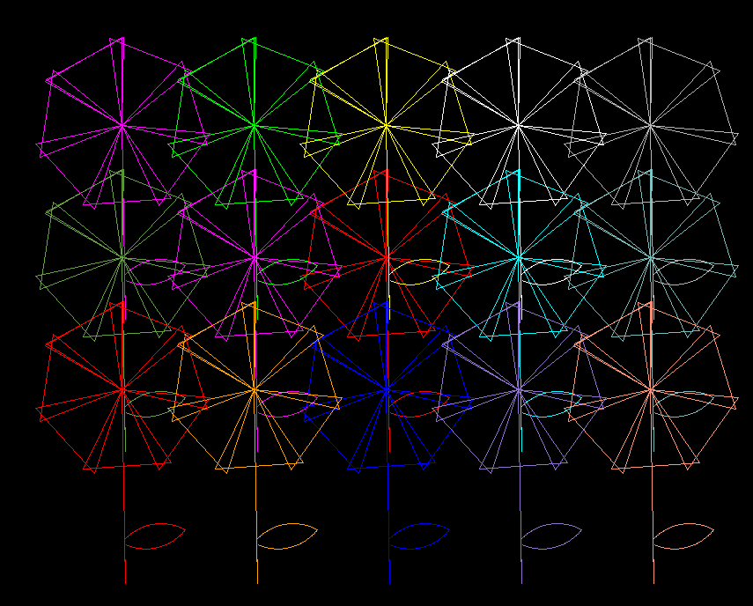

to flowergarden
setpencolor 4
flower1
right 90
penup
forward 150
left 90
pendown
setpencolor 3
flower1
penup
left 90
forward 150
right 90
pendown
setpencolor 5
flower1
penup
forward 150
pendown
setpencolor 6
flower1
penup
right 90
forward 150
left 90
forward 150
pendown
setpencolor 7
flower1
left 90
penup
forward 150
right 90
forward 150
pendown
setpencolor 2
flower1
penup
back 150
pendown
setpencolor 1
flower1
penup
right 90
forward 150
left 90
back 150
pendown
setpencolor 13
flower1
left 90
penup
forward 150
right 90
back 150
pendown
setpencolor 14
flower1
right 90
penup
forward 300
left 90
pendown
setpencolor 11
flower1
right 90
penup
forward 300
left 90
forward 150
pendown
setpencolor 15
flower1
right 90
penup
forward 300
left 90
back 150
pendown
setpencolor 12
flower1
left 90
penup
forward 300
right 90
pendown
setpencolor 10
flower1
left 90
penup
forward 300
right 90
forward 150
pendown
setpencolor 5
flower1
left 90
penup
forward 300
right 90
back 150
pendown
setpencolor 4
flower1
end


to rectangle1
forward 200
right 90
forward 100
right 90
forward 200
right 90
forward 100
end

