cmhart
1. Title
Book Locator

2. Description
The purpose of this program is to facilitate book finding within a Library. While libraries across Brown and elsewhere have computer systems that allow users to search for books by author, title, etc., the search only returns a call number that the user must manually match to a physical location. In particular, Brown has a system known as “Josiah” for this. Book Locator would allow the user to search using the same criteria (author, title, etc.), forward that query to Josiah to get the call number, and then match the returned call number with its physical location, displaying to the user a map showing the actual location of the book within the library.

3. Features (In order of priority [(a) being the highest priority])
(a) GUI:
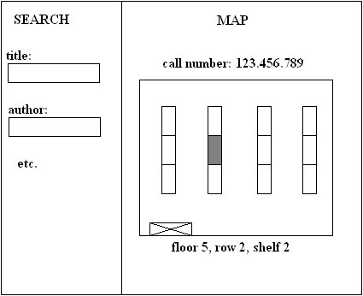

(b) Search. The search box should allow you to search by everything that Josiah would let you. When you first run a search, what Josiah would give you for results should appear where the map is in the picture above. The map should only be displayed after the user picks a specific book.

(c) Detailed Map. The map should be accurate down to the shelf. Depending on which library we choose, every floor or every big section of floor space should have its own map displaying every shelf in the area. In addition, it should contain other major objects, i.e. stairways, elevators, desks, etc. for reference purposes.

------------------------below here is optional--------------------------------------------------------

(d) A way for librarians to easily change where certain call numbers are kept. I think the simplest way to do that, since it would be done so rarely, is to have command line arguments that do that.

(e) Directions. Directions should be given from certain starting locations to the book. An idea for the starting location I have is the elevator, since everyone can usually find that without any trouble and it’s probably necessary to take it to get to the book anyway.

4. Users
The users of this software would be the exact same people that use Josiah at the library right now. It would be particularly useful to new students and anyone that is unfamiliar with the layout of a particular library.

5. Data Collection
The pertinent data are the layouts of each floor of the library and which call numbers belong to which shelves. The way I propose data be collected is to go to each section and note the beginning and end call numbers. From those, a good approximation would be to assume the call numbers are distributed uniformly across the shelf between the beginning and ending call numbers.

6. Testing
Testing should be pretty straight forward. The only major thing that needs to be tested aside from looking for bugs in the code is if all the call numbers were accurately mapped to their proper shelves. This can be accomplished simply by looking up books and making sure they actually are where the program says they are.

7. Divisibility
The project should be divided into the following parts:
(a) The GUI
(b) Creating the map
(c) Collecting data on which call numbers are on which shelves
(d) Interacting with Josiah (This one guy at the library may already have some code to help with this)

8. Project Specific Challenges:
(a) As I mentioned above, I want to make the assumption that call numbers are distributed evenly across a shelf. I’m not really sure how call numbers work, but if there is a strong tendency for there to be many books within some range of call numbers and few of other ranges of the same size, that might not be an accurate assumption. The librarian I talked to said that might not work, and she recommended instead to keep the map as general as just giving the range where a book could be, which is another option.

(b) If a librarian decides to move a shelf or two, which probably happens fairly often, a new map has to be made for that floor. That is time consuming and requires someone very familiar with the program. It’s not a change the librarian could quickly enter into the computer.

