Readings from Visual Cues, Practical Data Visualization by Peter and Mary Keller

Visualizing Data: Focusing on an Approach

The very abundance of visualization techniques can make selecting the one most appropriate for bringing out the meaning in data a perplexing search - a difficult, frustrating, and time-consuming aspect of visualization. If your thought process is like ours, you most likely rely first on experience. If nothing appropriate suggests itself, you may turn to other convenient sources: programs that colleagues are currently using or a new technique a friendly programmer offers. In each instance, you study the resulting image for any useful information it may reveal. This reflexive “try, then study" approach may eventually yield an image that reveals the meaning in the data, but it is just as likely to yield an image that is pretty but useless.

A methodology is needed for selecting visualization techniques, but the nascent discipline of scientific visualization does not yet have pat formulas for selecting appropriate techniques. A focused approach like that outlined in the following paragraphs is one we have found successful. It is meant to eliminate obstacles that may obscure valuable techniques.

In describing this approach, we have sometimes used a broad brush to depict a complex subject. Wherever we introduce a simplified view, we also refer you to texts with more detailed discussion. Our goal in simplifying is to quickly put an image of your data in your hands by shielding you from detail while building your understanding of scientific visualization.

The main points in our approach are to:

• Identify the visualization goal: We identify the meaning we seek in the data before we begin to construct an image. Knowing the goal, we may recognize new sources of techniques; meanwhile we have a focus for determining if a prospective technique is likely to reveal the meaning.

• Remove mental roadblocks: We regard data as nothing more than numbers bearing information to be visualized. When we think of data as belonging to some application or having some structure, we unnecessarily limit ourselves in imagining possible techniques.

• Decide between data or phenomena: We distinguish between data-representation and contextual-cue techniques. Data representation shows the data values independent of the phenomenon; the viewer must deduce the relationship to the phenomenon. Contextual-cue techniques relate the data values to the phenomenon being studied and add meaning to the visualization. Deciding whether data or phenomena are the focus further refines the visualization goal.

- Visual Cues
Identifying The Visualization Goal
Beginning data visualization by first identifying the visualization goal may give some pause, but we believe identifying the goal is the cornerstone in constructing an effective image. The goal is the meaning you hope to derive from the image, and, if appropriate, the meaning you want to communicate to others about your data. Identifying what you want to learn helps you select techniques that will produce an image communicating that meaning if the data support it. Just as a builder must know the building plan to select the correct construction materials, so too should you identify the desired result before proceeding to select techniques for visualizing data.

Usually data visualization consists of exploration, analysis, and then presenta-
tion - if the visualization is used to communicate with others.* Identifying the ultimate visualization goal may be evolutionary, reflecting the stage in the visualization process in which we are involved. Exploration, the searching of data for new relationships, usually means many trial-and-error data representations and requires interactive adjustment of data or image. Analysis, the study of known relationships among data, may require metrics or other precise means for comparison. Analysis and exploration are generally accomplished by one person or a few, and images that result need not be pretty or refined; they may even be unlabeled and, hence, meaningless to someone not familiar with the data or problem. Presentation is the "publication" of data for the benefit of others; the image should be aesthetically appealing, properly annotated, and intelligible.

How do you identify a visualization goal? Regardless of where you are in the visualization process, you need to ask such questions as Why am I looking at these data? What is important about the data? Am I comparing, associating, locating, verifying, finding, ranking, searching? What do I hope to learn? What do I want the image to say? What do the data prove? What do I expect the data to prove? In the exploration stage, the goal may be less focused than in the analysis and presentation stages. See Appendixes A and B for possible goals.

In fact, you are already identifying visualization goals, though perhaps subconsciously, when you input data to a graphics utility you have used for similar data. The unstated goal may be, “Compare this image with the prior image.” Or this idea might be at the back of your mind, “If it is wrong, I will know it,” meaning, “Verify the correctness,” or again, “Compare this image with the correct image.” The more you can focus the goal, however, the more effectively you can construct images. 11-1 provides a good example of how the visualization goal affects technique selection. Both images are constructed from the same data, but because each image uses a different color palette, each depicts different information. In 11-1, Figure A, the goal may have been “reveal shape,” and in 11-1, Figure B, the goal may have been 61 examine structure." Identifying the goal permits the selection of the appropriate color palette. The more specific the goal, the better focused and more useful the visualization.

Removing Mental Roadblocks
Here again, we suggest an approach that may seem untraditional. Our experience with scientists and engineers leads us to believe that many have been conditioned to regard data as some entity with inviolate properties. This rigid thinking may
________________________
- Some visualization specialists distinguish types of visualizations by the terms personal, peer, or presentation. We prefer to distinguish types of visualization by the terms exploration, analysis, and presentation, which emphasize the functional aspects of visualization
Section I: Effective Visualization 7

narrow the choice of techniques. We urge you instead to think of data only as numbers - numbers that a computer knows about. If data are only numbers, you can then consider any image-construction technique for the data. Treating data thus eliminates artificial constraints imposed by associating data with their origin (discipline or application), format or structure, or dimension. Instead you can consider any technique that will reveal the meaning in your data. This approach also diverts you from the common practice of using a familiar representation and then trying to figure out what you see in the representation.

Eliminating Constraints of Discipline and Application
Thinking of data as medical, mechanical-design, fluid-flow, oil-industry, satellite, or earthquake may focus you only on the image-construction techniques already used in that discipline. Techniques from a different discipline, however, might better represent data or might suggest modifications to the technique you are using. For example, if you have engineering data, you should not automatically use a CAD/CAM/CAE package for visualization. 2-4 and 2-11 visualize complex engineering data with general-purpose visualization techniques. 2-4 uses color and 3-D to visualize tensor qualities. 2-11 also chooses color and 3-D and adds glyphs. Of course, using a technique associated with the discipline from which your data come is often entirely appropriate. The important point is that you should select a technique because it produces the result you want, not because it is traditional in a discipline. Exploring the visualization techniques useful in other disciplines can enhance your ability to find those useful for your own data.

Eliminating Constraints of Format and Structure
Data-representation techniques do have specific format and structure requirements, and data in each discipline tend to be collected in specific formats and structures. For example, much of mechanical engineering data are geometry data, medicine data are image or scanned data, satellite data are signal (time-history) data. Therefore, selecting a technique with the same format and structure requirements that your data have seems logical. The data fit easily into the conventional utility requirements. But if the familiar or usual technique does not best depict your data, you should consider other techniques and not be deterred because your data are in a format or structure unacceptable for use with that technique. Data-conversion algorithms allow you to convert data to fit different requirements, and therefore to use other available techniques. It is usually easier to convert data to a technique to which you already have access than to write a new, equivalent technique.

Here's an example: you may think that an irregular (nonrectangular) array of real numbers cannot use imaging software because such software generally requires a rectangular array of integers from some image-scanning device. It is easy, however, to change the format of an irregular array from real to integer, and its structure, too, is easy to approximate with a rectangular array. The converted array can then use imaging software.

Among the images that use data conversion in Visual Cues is 8-4, an example of how data with one structure can be converted for use with an algorithm that requires a different structure. An algorithm generates a 2-D slice of data through a 3-D pressure field. The 2-D slice is then pseudocolored by a conveniently available algorithm and merged with the 3-D model to relate the data to the model. 10-5 provides another example of structure conversion. The data, originally represented on a square mesh, were converted to an irregular triangular mesh to take advantage of increased rendering speed.

8 Visual Cues
Other algorithms that convert or modify data take randomly positioned data and convert them to regularly positioned data, minimize noisy data with smoothing algorithms, or create planar data by passing a plane through a volume of data.

You can find algorithms for data conversion in numerical analysis and computer graphics journals. Also, each of these four books describes a few conversion algorithms: Andrew S. Glassner, ed., Graphics Gems (San Diego: Academic Press, 1990); James Arvo, ed., Graphics Gems II (San Diego: Academic Press, 1991); David Kirk, ed., Graphics Gems III (San Diego: Academic Press, 1992); and William H. Press et al., Numerical Recipes (Cambridge, Eng.: Cambridge University Press, 1986).

We urge you not to hesitate to convert data to a different format or structure because you fear that conversion may introduce errors in approximation. Such errors, though harmful if the data are to be used for continued simulation, generally cannot be discerned in the data representation of an image. Ignoring conversion errors, especially in the exploration phase of visualization, encourages rapid evaluation of techniques. Our experience shows that positional errors introduced are small and errors for data values even smaller. Whether these errors are tolerable depends, of course, on the application. An architect's plan for uniform air temperature in a small room is less critical than a surgeon's plan for risky, delicate surgery. Generally, though, errors are tolerable during exploration but must be accounted for in analysis.

Data conversion can be a complex, tedious issue that may have to be addressed for accurate analysis. But if you find a visualization algorithm you want to use, we suggest that you convert your data to the algorithm's input format and structure rather than rewrite visualization algorithms to work with the format or, worse yet, forgo constructing a meaningful image because you think your data cannot be used with the algorithm.

Eliminating Constraints of Dimension
Thinking that the representation's dimensions or number of variables must be the same as those in your data can also channel your thinking and eliminate useful techniques. For example, in selecting a representation technique you can often treat a 2-D scalar field and a (single-valued) 3-D surface as the same kind of data set. You can then use the same visual techniques for both kinds of data. 7-3 illustrates how a 2-D scalar field can be represented as a 3-D surface. Conversely, a 3-D surface can be projected on a plane and the values treated as 2-D, a technique commonly seen in U.S. Geological Survey maps, for which data on elevation are projected to a plane that is then represented as a contour map. With either data set, the 2-D representation can be a contour plot or pseudocolor plot, and the 3-D representation can be a shaded surface. The shaded surface could also include isolines and color.

Nor should the number of variables limit your representation choices. A variable is said to be a dependent if it is a function of another variable (called an independent variable). In the equation y = f(x), x is the independent variable and y is the dependent variable. You can use the common x-y scatterplot to study the relationship. If you have a two-variable data set x and y (say temperature and humidity), where x and y are measured at the same point, you have two variables. There is no defined relationship. You can visually determine if there is a relationship, though, by using the same x-y scatterplot as you used to show the relationship between the independent and dependent variables. In using a visualization technique, it often does not really matter whether you have two variables or one dependent variable
Section I: Effective Visualization
and one independent variable. Whether it makes sense to choose the technique is another question, determined by what you are trying to learn from the image, not by the relationship between the variables.

Multivariate data can be especially challenging because of the many dimensions or variables. We illustrate several ways of handling multivariate data in the multivariate category of Section II. Also, the dimensionality of multivariate data can sometimes be reduced by combining variables and then analyzing the data. 2-1 uses a three-variable technique effectively to analyze the relationship of four variables. On the other hand, data can be redundantly encoded to permit low-dimension data or data with a few variables to use a technique that requires higher-dimension data or more variables. 7-2 illustrates data redundantly encoded to height and color. An effective technique for handling multivariate data is to divide and conquer by representing each variable relative to another on a scatterplot. If random structures appear in some scatterplots, they may indicate a less important relationship between the variables. The variables related to the random-appearing scatterplots may be ignored for the moment, resulting in a lower-dimension data set to investigate.

Our aim is not to describe all possible ways of thinking about data, but to show that the same data set considered differently allows you to imagine different representations. The appropriateness of the representation will depend on the data.
Deciding Between Data or Phenomena

Techniques are the collection of rules, procedures, and algorithms whose system-atic application produce an image that communicates the meaning implicit in data. We distinguish between the data-representation techniques that represent the numeric values of data and the contextual-cue techniques that provide additional clarifying, interpretive meaning to the representation of the data.

Data-Representation Techniques
Data-representation techniques are those well-defined algorithms that take data as input and deliver an image as output. A simple example is the 2-D contouring algorithm, which takes a 2-D array of values and returns a set of isolines. Surface plots that show shape and texture; volumetric plots, which include a number of techniques that expose relationships in 3-D; x-y plots; scatterplots, histograms, and bar charts are other techniques for representing data.

Contextual-Cue Techniques
Visualization achieved by contextual-cue techniques is somewhat equivalent to the special effects with which photographers, artists, and moviemakers deliver meaning to viewers. The cues may result from parameters in the computer program that control the output's appearance from a data-representation algorithm, or they may be the special effects introduced in the image by adding or removing other graphic elements. Contextual-cue techniques are usually applied apart from the data-representation algorithm; examples that suggest the properties of the phenomenon being studied are models, coastlines, motion blur, haze, hounding boxes, perspective, and color. The techniques can also make representations of data values and relationships more readable, such as numbered scales and grid lines that make values readable or the color, size, and position of abstract objects that suggest value and relationships.
10 Visual Cues
Relating Data to Context
For an image to clearly communicate a visualization goal, you usually must
incorporate both data-representation and contextual-cue techniques in an image.
The need to distinguish between and to use both kinds of techniques brings to mind
Hamming's statement:

The purpose of computing is insight, not numbers.

To provide insight you must do more than symbolically represent the numeric values of data; you must also relate those values to the phenomenon that the data represent. We offer the following simple example to show the additional insight communicated by using contextual cues that represent or identify the phenomenon.

Assume we have a 100 x 100 square array of numeric data values to examine. Pseudocoloring the values according to the visible light spectrum (blue, low; red, high) reveals a cluster of red that locates the maximum. Now we have an image that conveys the relative value of the numeric data. What does this cluster actually represent? The scientist studying the data values knows the cluster represents temperature measurements of a circuit board on which the components that are running too hot are to be identified and replaced. The meaning communicated by the image, however, is simply, "high values are located."

If on the array of colors we use contextual-cue techniques to superimpose labeled, white, rectangular outlines representing individual components on the circuit board, the cluster of red now locates and identifies the hot component and the meaning becomes "hot circuit component identified." We have changed our emphasis from relative values of the data to meaning of the data by also showing the phenomenon the data represent.

Initially in constructing an image, you may use only data-representation techniques that visualize the numeric values of data. But for effective presentation to those unfamiliar with the data, an image that represents the phenomenon is a necessity. We also believe that even for those familiar with the data, a representation of a phenomenon is more valuable than a numeric representation. A phenomenon representation more clearly reveals the meaning and more accurately presents the information. 8-4 illustrates the increased meaning available in such a representation. In the figure, color depicts numeric values of a 2-D pressure field. Those familiar with the origin of the data know that a launched space shuttle creates the pressure field. But even for them, superimposing the context, the 3-D model of the shuttle, instantly shows the relationship of the pressure field to the shuttle configuration.

Representing Phenomena
When phenomenon is your focus, you should select techniques that create cues corresponding as closely as possible to the viewer's experience with the phenomenon. Color, shape, texture, or setting may suggest the phenomenon: blue can suggest water, arrows can suggest projectiles. 2-13 and 7-8 choose color to suggest the properties of the phenomena being studied and to help the viewer draw conclusions. 10-8 applies color to suggest the planet Mars and photographer's tricks to add the depth cues. The teacup in 10-4 provides the setting that indicates the fuzzy white objects are steam. 1-1 adds lines describing the shape of the world and its continents to bring meaning to the measured ozone data. The shape the data describe can also suggest meaning, as in 10-2, where the viewer recognizes the shape as that of a backbone.

Section I: Effective Visualization 11
Choosing techniques to represent the phenomenon may require some creative or artistic talent, especially if the phenomenon is abstract or has never been seen, such as the inside of a proton, or a black hole. To illustrate such phenomena, you may add abstract cues to suggest the expected environment of the phenomenon, as in 6-3, where color represents the quark property and motion blur and position illustrate interaction in a phenomenon never seen.

Ideas for contextual cues may be found in art books, design books, television commercials, and, closer to home, in Edward R. Tufte's Visual Display of Quantitative Information (Cheshire, CT: Graphics Press, 1983). The data-representation techniques are usually found in graphics systems or graphics libraries, such as PV-Wave, AVS, Explorer, and NCAR Graphics. More recent data-representation techniques can be found in the Graphic Gems series previously cited in this section.

Constructing Ideal Images
The continuum of understandable visual techniques seems to reach from

Instantly understandable to
Takes some study time to
Requires additional schooling.

The ultimate goal of visualization is to create complete images that "speak" to the viewer without additional explanation. To demonstrate what we mean when we say "speak," we ask you to recall computer-generated images or to thumb through the images in this book. Some will simply and clearly speak to you-you will understand the images immediately. Others will require some time to view and ponder, but then you will understand. And no matter how long you study some images, they will be no more than images-they will not speak to you. We realize immediate understanding may not always be attainable, but we believe you must have such a goal for each image Test the image (and by implication, you) communicate poorly or imprecisely, or not at all. We assert that the end purpose of an image is to facilitate communication of knowledge, not merely to display or represent data.

To understand the challenge of visualization, we compare art and scientific visualization to show why visualization may be so difficult. Both have the goal of communicating visually and symbolically. The artist, in using such established tools as canvas, brushes, and oils to illustrate a point of view, benefits from the knowledge of centuries. The tools of scientific visualization-output device, data-conversion software, software to depict data - as well as the knowledge of how to use them are still evolving. The computer's power is needed to handle voluminous data, convert data, and apply visual techniques that reveal and communicate meaning hidden in data. The available computer tools, however, sometimes impair or limit ability to display data meaningfully or artistically. Scientific visualization is in its infancy. Computer artistry is a long way from representing data with the proficiency of a Michelangelo, Van Gogh, or Picasso.

Meaning and beauty are in the eye of the beholder. For any set of data, a spectrum of correct representations could accomplish the visualization goal, but even more representations would not. The correctness of a representation depends on your purpose. A complex, obscure representation might be quite adequate for personal use, but a general audience will need a simplified, obvious representation. Again, the goal for any representation is to make information about the data values or the phenomenon clear and immediately obvious to the viewer.

12 Visual Cues
Conclusion

To facilitate constructing images that effectively communicate the meaning of the data, we advocate thinking of an image as comprising a visualization goal, one or
more data sets, and a collection of techniques, each deliberately chosen to communicate the meaning that is in the data. The data are numbers that can be converted or transformed to be input to any representational technique.

Although we suggest not classifying data so that other data-representation techniques can be considered, it is certainly possible that the best visualization is the one commonly used with those data. The best solutions to problems in data visualization result from considering the possibilities and selecting the most appropriate. And if the familiar technique best communicates the meaning of the data, then it is the most appropriate. If you have a technique that works, by all means use it. Understanding is always the goal.

The relationship between the visualization goal and the choice of techniques for accomplishing that goal is just beginning to be understood. Appendix A lists generic visualization goals, suggests techniques to accomplish the goals, and points to examples from Visual Cues that depict the techniques. Appendix B formalizes the relationship between goal and technique by defining terminology to use in classifying the goals.

Section I: Effective Visualization 13

Keller Images Below

Surface and Slice 8-1

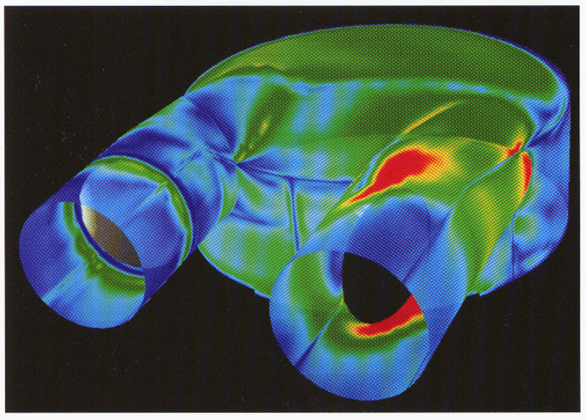
1 dependent variable
3 independent variables
Locates regions
Medicine

Pseudocolored surface
of a 3-D model quickly
locates regions of high
values

Chris Gong, Cetin Kiris,
Dochan Kwak, and Stuart
Rogers, NASA Ames Research
Center, Moffett Field, CA,
USA.

Application (Biofluid Mechanics)
The Penn State artificial heart model is studied to locate regions of high vorticity so that the internal chamber can be appropriately designed. High vorticity implies high shear stress, which may result in damage to blood cells flowing near the solid boundaries. The computation was performed on a Cray Y-MP supercomputer and rendered on a Silicon Graphics IRIS workstation using NASA Ames PLOT3D; SURF; GAS; and Mrakevec.

Technique
Pseudocoloring the model's interior surface locates maximum vorticity: blue, low; red, high. Making the model 50% transparent reveals internal mechanical structure to demonstrate how high vorticity is related to the physical features.

Hints
Making the model 50% transparent is a useful technique for relating internal structure to surface values. ~ Although 3-D vorticity data are throughout the volume, the image is simplified by representing only the data that touch a surface.

Section II: Illustrated Techniques 115

Volume 9-2

1 dependent variable
3 independent variables
Reveals shape
Chemistry

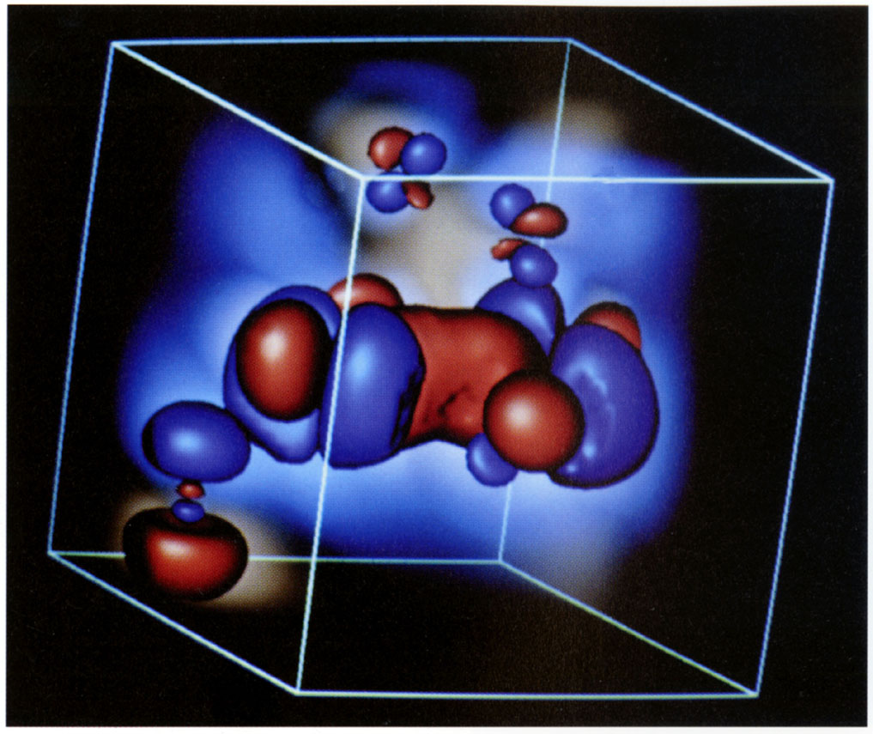
Colored isosurfaces
reveal shape and
colored haze indicates
region of field effects.

Wolfgang Krueger, GMD-
HLRZ, Bonn, Germany.

¹Data provided by L.
Noodleman and D. Green,
Scripps Clinic, La Jolla, CA.

2 Wolfgang Krueger, "The
Application of Transport
Theory to Visualization of 3-D
Scalar Data Fields," Computers
in Physics 4, 4 (July/August
1991): 397-4O6.
³Wolfgang Krueger, "Volume
Rendering and Data Feature
Enhancement," Computer
Graphics 24, 5 (November
1990): 21.

Application (Molecule Visualization)
A solution of the Schrodinger equation is used to generate the 3-D data for the psi-
function of an iron protein molecule.1 The simulation to create the data was run on
a supercomputer. The image was rendered on a Silicon Graphics IRTS workstation
with in-house volume-rendering software, which is based on transport theory.*

Technique
This image is created using a transport theory2' 3 approach to reveal shape and field effects. Spatial decay of the field is indicated by the colored haze; the isodensity surfaces are created opaque with highlights and shading; and the sign of the field is indicated by color. The colored, realistically lighted isosurfaces reveal shape, and the colored haze indicates the area of field effects.

Hints
This technique can be used to model any 3-D scalar field where it is important to visualize spatial decay of some variable relative to an isosurface of the variable.

* The visualization approach is based on the linear transport theory for the transfer of particles in inhomogeneous amorphous media. The advantages of this approach are its rigorous mathematical formulation, applicability to data from different disciplines, and wide variety of contextual cues.

Section II: Illustrated Techniques 127

Volume 9-4

1 dependent variable
3 independent variables
Depicts shape
Mechanical Engineering

Translucent isosurfaces
depict the shape of a
3-D scalar field.

Richard S. Gallagher, Swanson
Analysis Systems, Houston,
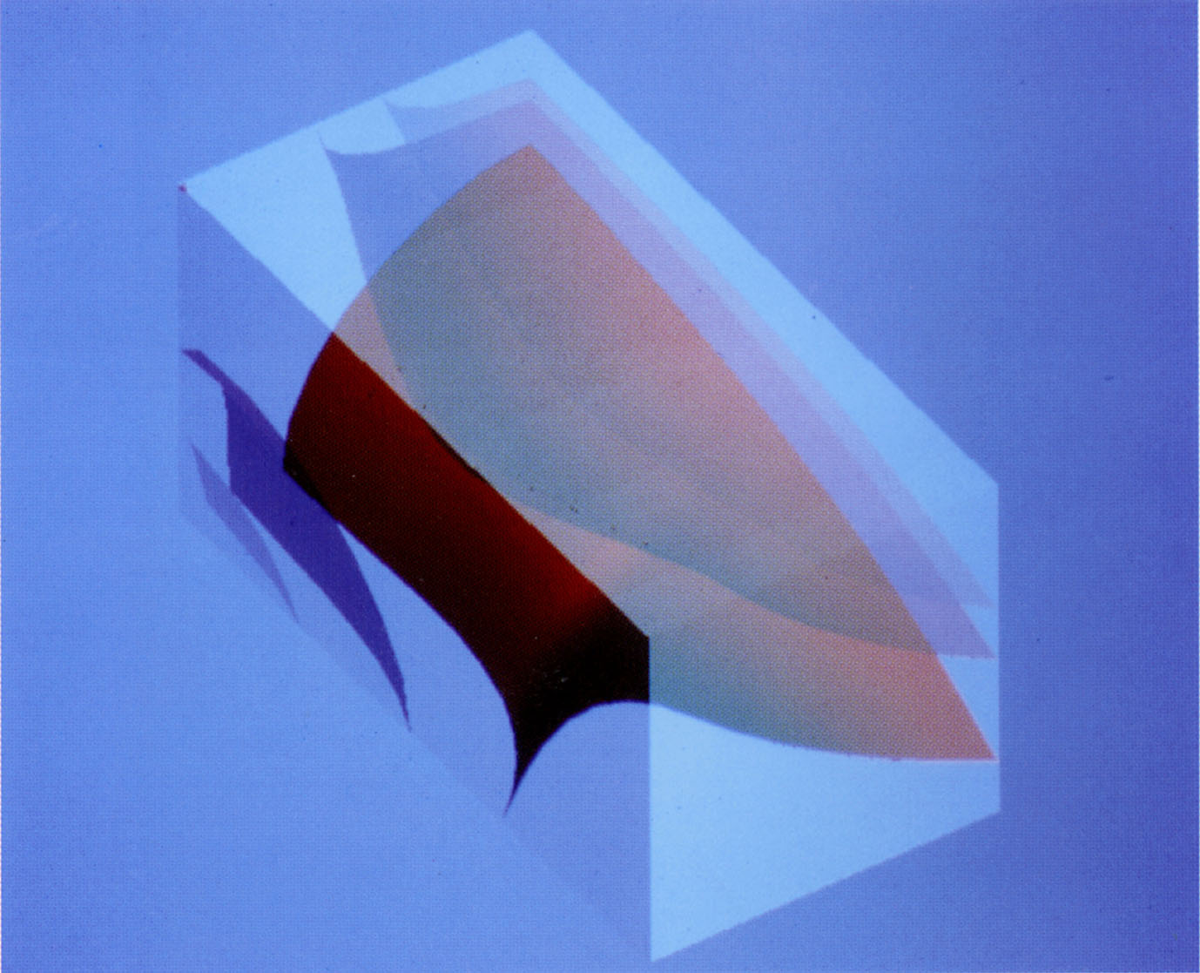
PA, USA; Joop C. Nagtegaal,
Hibbitt, Karlsson & Sorensen,
Inc., Providence, RI, USA.

Efficient 3D Visualization
¹Richard S. Gallagher and
Joop C. Nagtegaal, "An Technique for Finite Element
Models and Other Coarse
Volumes," Proceedings of
SIGGRAPH '89, in Computer
Graphics 23, 3 ~August ~989).

² William E. Lorensen and
Harvey E. Cline, "Marching
Cubes: A High Resolution 3-D
Surface Construction Algo-
rithm," Proceedings of
SIGGRAPH '87, in Computer
Graphics 21, 4 (July 1987).

Application (Finite Element Analysis)
This study of stress distribution within a solid model was computed on a VAX 8600 and rendered on a Tektronix 4336 workstation with hardware Gouraud shading and translucency.

Technique
A surface plot shows isosurfaces of stress values throughout a solid. At the vertices of a coarse volume grid, bicubic surfaces are constructed' from the stress values and gradients of these values. A separate bicubic interpolation of surface geometry and surface normals is performed to guarantee visual continuity between surfaces generated from adjacent volume elements. The image is rendered with a surface-based extension to the Marching Cubes algorithm.2 The degree of translucency is varied with the magnitude of the scalar value: isosurfaces of higher values are more opaque. The exterior visible surfaces of the volume are shown with translucency to provide a physical frame of reference without occluding the data.

Hints
Rotating the image to allow different vantage points helps us see the actual shapes of the isosurfaces. Just as isolines show the shape of a 2-D scalar field, the isosurface shows the shape of a 3-D scalar field. ~ See also 9-5 for the use of color to represent the shape of a 3-D scalar field. ~ Comparing this example with 9-5 suggests that interactively adjusting the number of surfaces and the viewing orientation will help optimize the image's information content.

Section II: Illustrated Techniques 129

9-5 Volume

1 dependent variable
3 independent variables
Depicts shape
Computational Fluid Dynamics

Isosurfaces depict shape
of a 3-D scalar field.

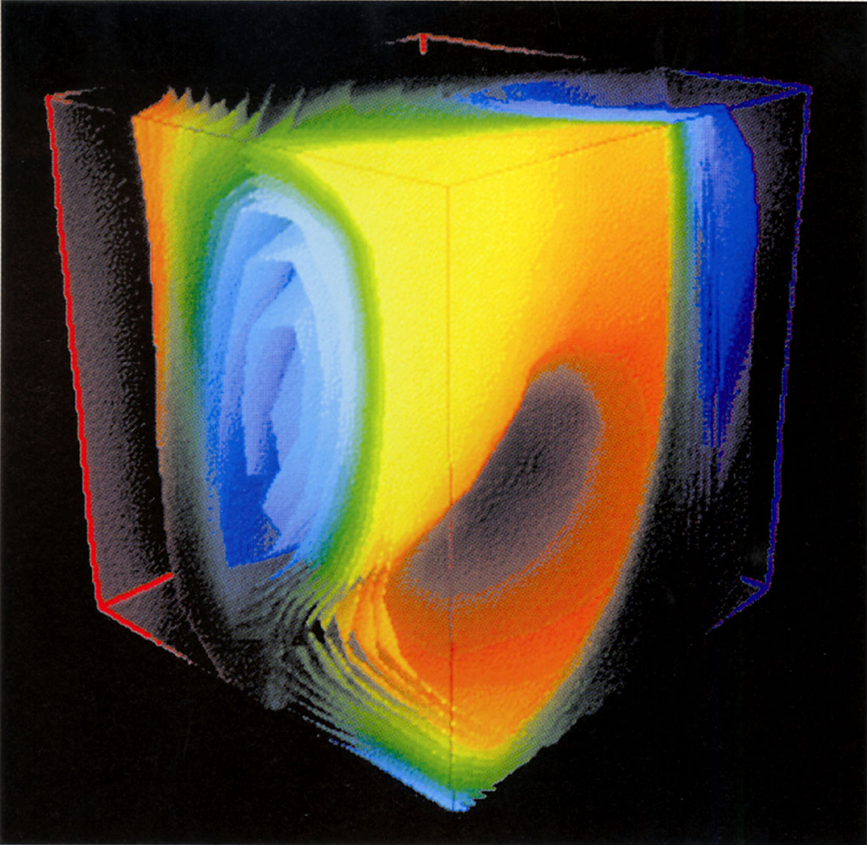
Alexander Gelman, Vincent A.
Moosseau, and Mark J. Oliver,
Idaho National Engineering
Laboratory, Idaho Falls, ID,
USA.

'J. Bloomenthal,
"Polygonalization of Implicit
Surface," Computer Aided
Geometric Design 5 (1988):
341-355.

Application (Heat Convection)
A simulation describes a gas-filled room with a heat source (red edges) and a heat sink (blue edges). The data were computed on a Cray X-MP supercomputer using the in-house HOTFLO gas simulation code. The image was then visualized on a Silicon Graphics 4D 22()-GTX workstation with in-house visualization software.

Technique
Approximately ~5 isosurfaces are generated with a modified Marching Cubes algorithm adapted from Bloomenthal's method.1 Isosurfaces are colored according to the visible light spectrum (blue, cold; red-orange, hot) to accentuate the distribution of temperature within the volume. Rendering the isosurfaces inside a transparent volume delineated by edges gives the feeling of dimensionality. Volume edges are colored to indicite the boundary temperature conditions.

Hints
Bloomenthal's method rapidly generates surfaces suitable for real-time interactive animation. ~ Users of the method should be aware that in some geometries the method breaks down, resulting in "holes" in objects. These holes, which may not be seen in animations at 30 frames per second, can be very obvious and therefore misleading when analyzing a single image. ~ See 9-4 for another example of representing the shape of a 3-D scalar field, but using fewer surfaces and just one color.

130 Visual Cues

Multiform Visualization 11-1

A
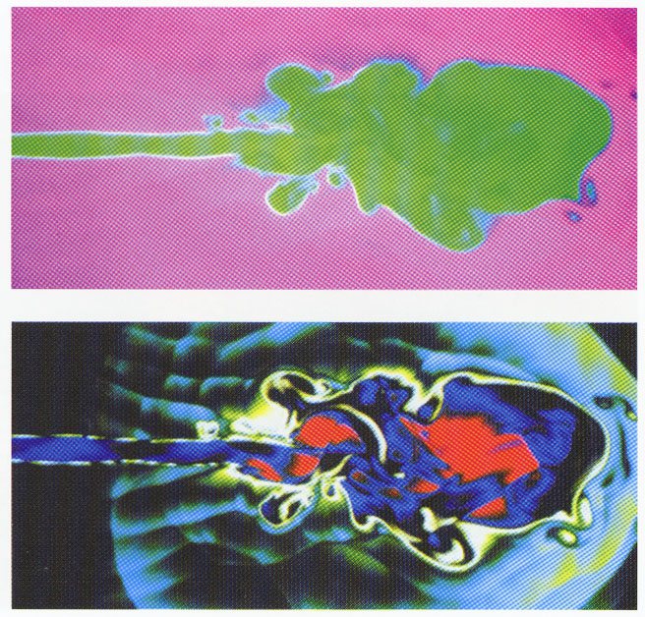
1 dependent variable
2 independent variables
Reveals structure
Astronomy

Proper choice of color reveals structure.

Donna J. Cox, National Center for Supercomputing Applications, School of Art & Design, University of Illinois, Urbana, IL, USA; Michael Norman, National Center for Supercomputing Applications.

Application (Computational Astrophysics)
This simulation using a magnetohydrodynamics code shows the density of matter in an astrophysical jet in intergalactic space. Complex flow patterns and vortices are modeled. Images were rendered on a Silicon Graphics Workstation with data from an in-house application code on a Cray supercomputer.

Technique
Before-and-after pseudocolor maps constructed from the same data illustrate the dramatic change in meaning communicated by changing the color table. Changing the color that a data point receives reveals hidden structure in Figure B by creating color contrasts that the eye is better able to discern. 1

Hints
A color key as in Figure iv, page 4~, that illustrates the color table should be included if it is important to correlate color to the variable's value. ~ Another technique, histogram equalization, used in 11-3, could automatically bring out detail. A more reliable way of discovering patterns, however, is to manually and interactively step through a collection of color tables.

¹ D. Cox, "Using the Supercomputer to Visualize Higher Dimensions: An Artist's Contribution to Scientific Visualization," Leonardo: Journal of Art, Science and Technology 21 (1988): 233-242.
² D. Cox, "The Art of Scientific Visualization," Academic Computing (March 1990): 20- 40; references at end of journal.
³ G. Meyer and D. Greenberg, "Perceptual Color Spaces for Computer Graphics," Proceedings of SIGGRAPH '80, in Computer Graphics (July 14-18, 1980).

Section II: Illustrated Techniques 147

11-8 Multiform Visualization

A B

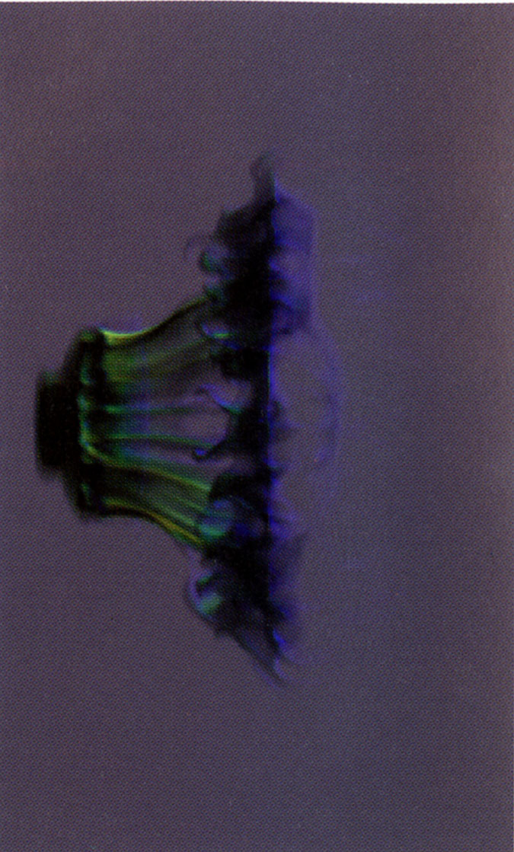
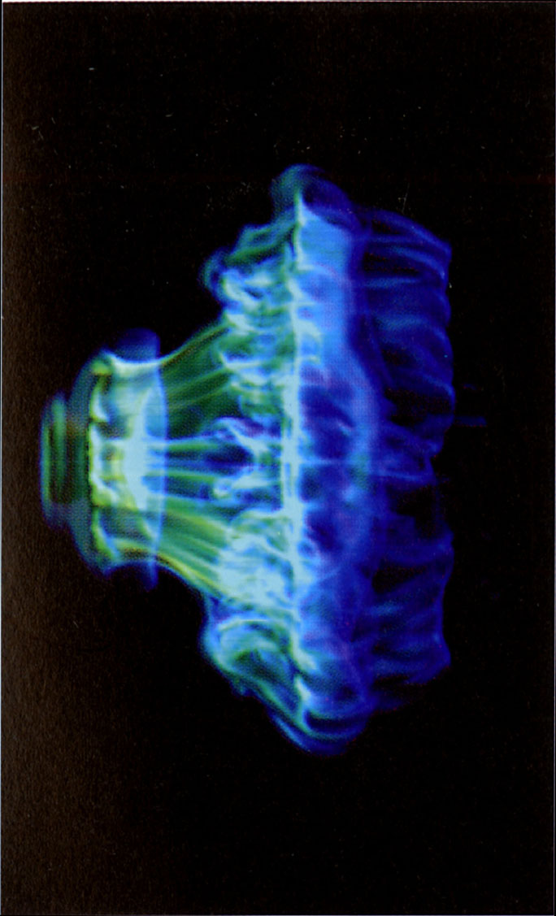
1 dependent variable
3 independent variables
Reveals structure
Computational Fluid
Dynamics

Minute adjustments in
opacity and background
reveal structure.

Richard I. Klein, Michael J.
Allison, and Thomas M.
Kelleher, Lawrence Livermore
National Laboratory, Livermore,
CA, USA.

Application (Turbulent Fluid Flow)
The structure of fluid flow is studied by modeling the changes that occur when a spherical, interstellar cloud is subjected to a strong shock from a supernova explosion. The computational model was executed on a Cray Y-MP supercomputer and rendered on a Stardent computer with in-house software.

Technique
The computational model's 3-D adaptive mesh is first converted to a rectilinear mesh and volume rendered with the compositing alpha-blend algorithm"2 with the low-density and high-density values opaque. From the many images of the same data set rendered, two are shown here. Figure A shows the data with the very low-density fluid omitted so that structure occluded by that fluid can be observed. Figure B shows the very low-density fluid but uses a black background to enhance contrast to reveal complex, connected, very low-density structures.

Hints
Rotating the image, removing data, and changing opacities sometimes reveals more than one expects. Researchers originally thought the data had very little structure. Rotating the image, however, provided vantage points suggesting an intricate structure hidden by cloud material; that matter was then removed by selectively plotting data and adjusting opacity.

¹Andrew Barlow, "New Workstation Graphics for Engineers," Computer-Aided Engineering 9, 9 (September
1990): 40.

² K. Akeley and T. Jermoluk, "High-Performance Polygon Rendering," Computer Graphics 22, 4 (August 1988): 239-246.

154 visual Cues

11-10 Multiform Visualization

1 dependent variable
3 independent variables
Reveals structure
Combustion Engineering

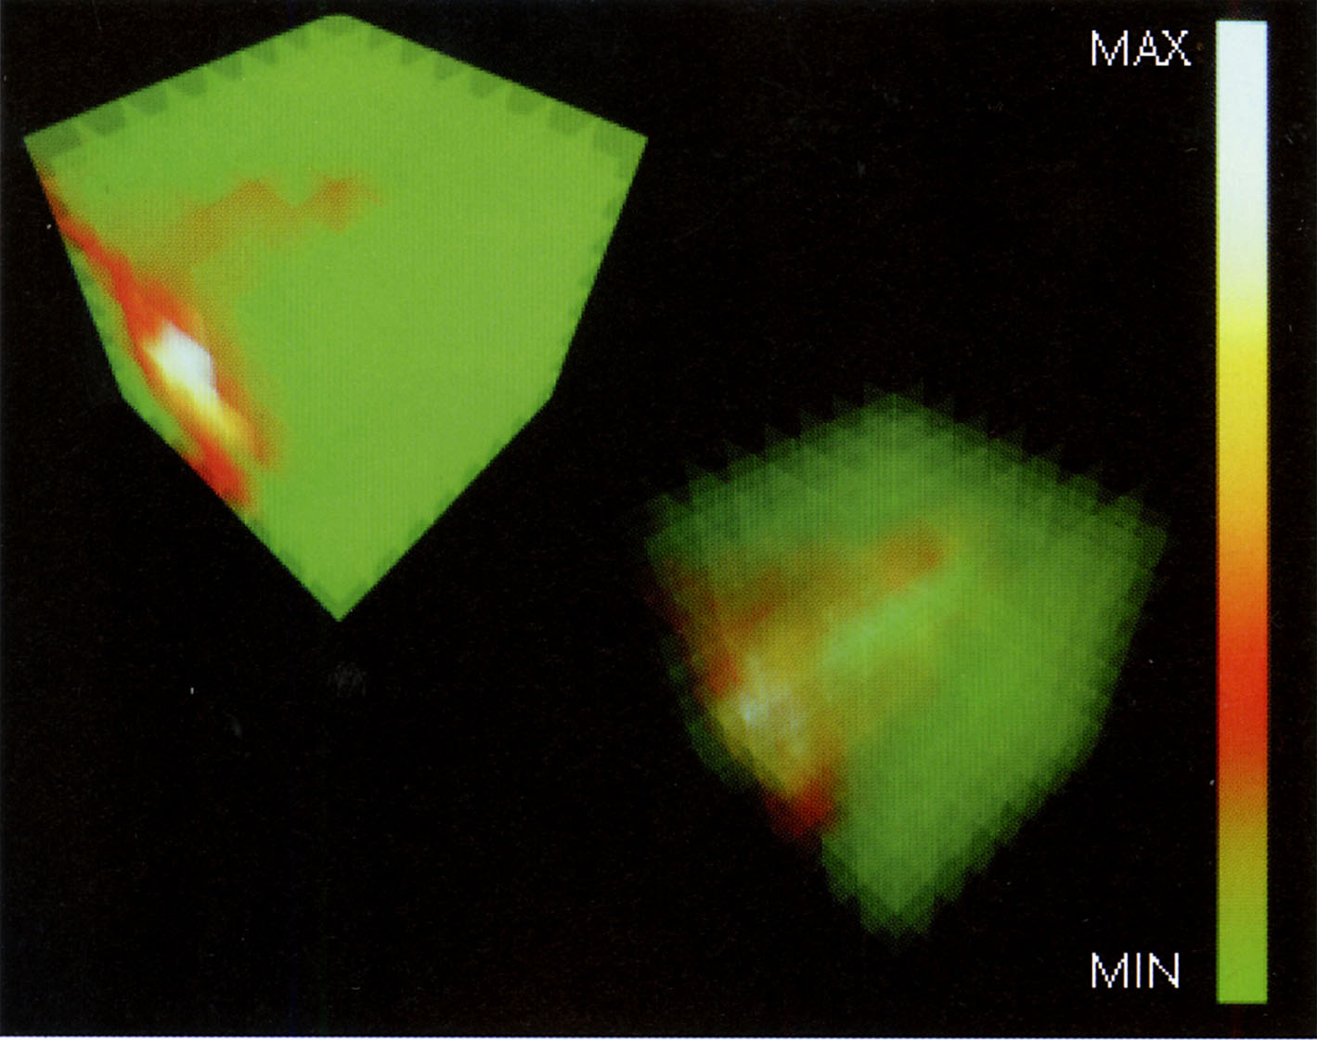

Translucency reveals
structure within a
volume.

Gregory M. Nielson, Arizona
State University, Tempe, AZ,
USA; Bernd Hamann, Missis-
sippi State University, Jackson,
MS, USA; Marshall Long, Yale
University, New Haven, CT, USA.

Application (Computational Fluid Dynamics)
The distribution and concentration of gas in a region containing a flame is studied.¹
In-house software with the Silicon Graphics GL library was run on a Silicon
Graphics 4D 320 workstation.

Technique
In this volumetric technique for visualizing 3-D data and functions, the domain is decomposed into a number of voxels; then each voxel face is treated as translucent. The parameter that controls the level of transparency can be changed, allowing the user to look deeper and deeper into the data.2 A The left-hand image shows the transparency variable set to opaque, and the right-hand image shows the parameter set to more transparent to reveal internal structure. The color key at right correlates the highs and lows in the data.

Hints
If the domain is decomposed into a large number of voxels, the rendering time becomes extremely long and the effectiveness of interactive analysis is reduced. ~ Rotating the cubic volume provides different perspectives to help understand the structure. ~ Different color tables may bring out other information, as in 11-1.

'Marshall B. Long, Kevin Lyons, and Joseph K. Lam, "Acquisition and Representation of 2D and 3D Data from Turbulent Flows and Flames," in scientific Visualization, G. Nielson and G. Shriver, eds. (Los Alamitos, CA: IELE Computer Society Press, 1990), pp.132-139.

² Bernd Hamann, "Visualization and Modeling Contours of Trivariate Functions," Ph.D. Thesis, Arizona State University, Tempe, AZ (1991).

³Gregory M. Nielson, Thomas A. Foley, Bernd Hamann, and David Lane, "Visualization
and Modeling of Scattered Multivariate Data," Computer Graphics and Applications 11, 3
(May 1991): 47-55.

⁴See additional references at the end of Section II, p.182.

156 Visual Cues
Artistic Cues 12-9

Artistic depth cues
achieve a 3-D
impression.

Gregory MacNicol, Santa Cruz,
CA, USA.
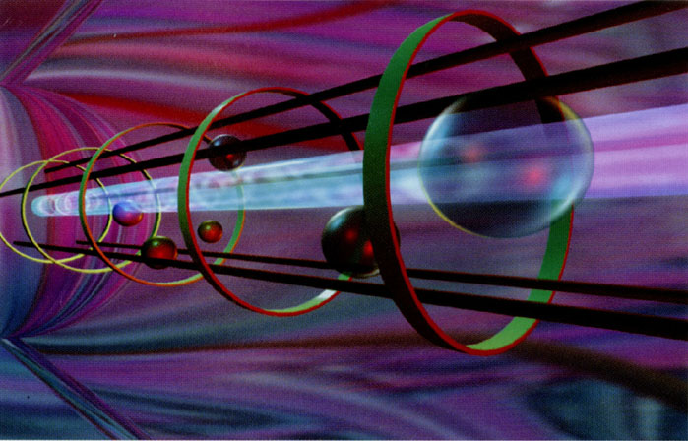

Application (Artistic Exploration)
This imaginary scene was created to evaluate the rendering options and output quality of Crystal Graphics's Crystal 3D software running on a Micronics 486 with a Targa graphics board.

Technique
Perspective, opacity, color, and reflection are combined to give the 3-D effect. Objects converge and shrink, spheres become more opaque, and the color striations in the reflection narrow as they recede.

Hints
Unlike some techniques that require powerful computers, tools for creating and enhancing 3-D images such as this one are readily available on small desktop computers. ~ Artistically manipulated, desktop tools can create effective representations, such as the light beam in this image, which varies colors to suggest fluctuations in beam intensity~ (This same "beam" technique can be used to convey the motion of a high-velocity object, such as a comet or particle beams, or to convey electromagnetic radiation.) ~ By selecting eye-pleasing, coordinated colors that unify the image, the artist attracts viewer attention while improving comprehension and retention of information. Such unifying elements make any image more effective and help communicate.

Section II: Illustrated Techniques 167

12-7 Artistic Cues

3-D Model
Reveals hidden information
Computer Art

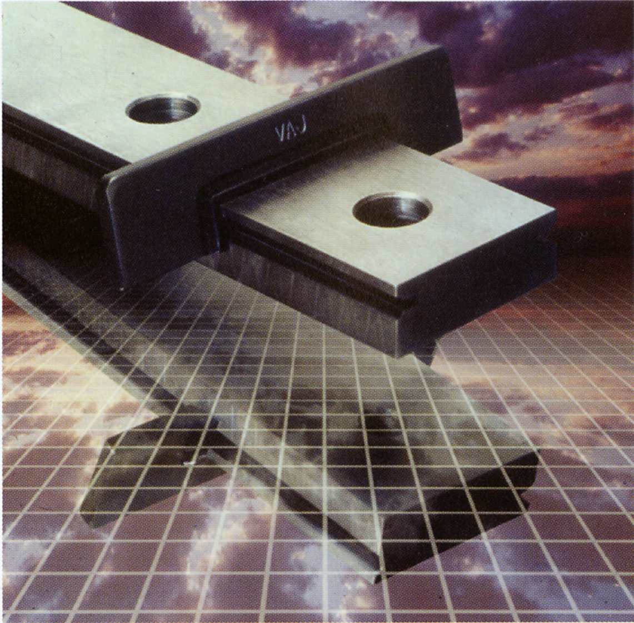

Reflective surface
reveals hidden side

Tullia Redaelli Spreafico, RGB,
Computer Graphics, Milan, Italy.

Application (Commercial Art)
The image, which appears on the cover of a company brochure, was generated with
Time Art's Lumena and Crystal Graphics's Crystal 3D software on a PC compatible.
Technique
Two digitized and retouched photos and one computer-generated reflective grid are combined to form this image. Reflecting the main object on the shiny grid cleverly reveals the object's hidden side and also shows that the object is slightly raised at one end. The reflection, lighting, shadows, and the receding-square grid create the 3-D effect. The clouds contribute a context, convey secondary information, create eye appeal, and set a mood.

Hints
Using a reflection to reveal a hidden side can eliminate the need for additional images to show details of an object. ~ 5-6 and 8-3 show another format for revealing hidden information using shadows. ~ The sides of the box in 8-3 could also be changed to reflective surfaces to reveal the hidden sides.

Section II: Illustrated Techniques 165

